CSOPESY Semi-Major Output 2 | Prepared By: Gregory Cu  Created By: Neil Patrick Del Gallego, PhD
By group

Updated as of: Sept 18, 2026
General Instructions: Desktop-Style OS Mock-up

Implement your own desktop-style OS mockup, using dear IMGUI - an immediate-mode UI library. Just as Windows, macOS, and Android have a compositor that manages windows and renders the desktop every frame, your CSOPESY emulator will have its own compositor built on top of the GLFW + OpenGL + Dear ImGui stack. The mockup must simulate the visual experience of a minimal operating system shell — not a fully functional OS, but a convincing, real-time graphical environment that demonstrates mastery of immediate-mode UI design.

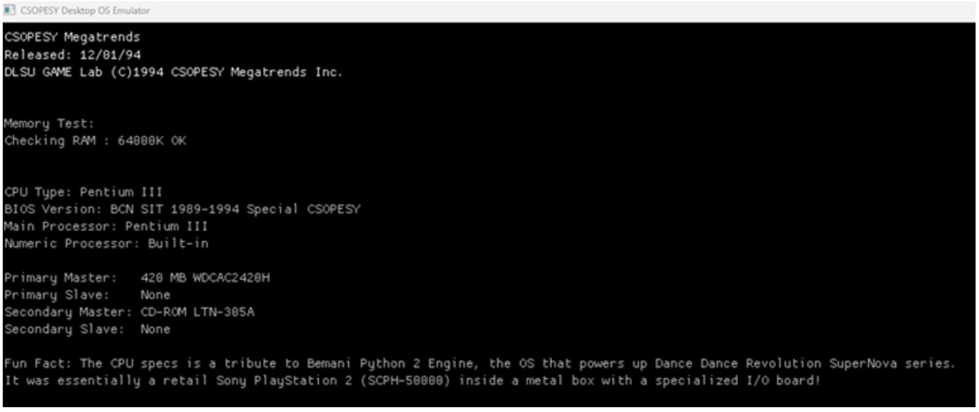

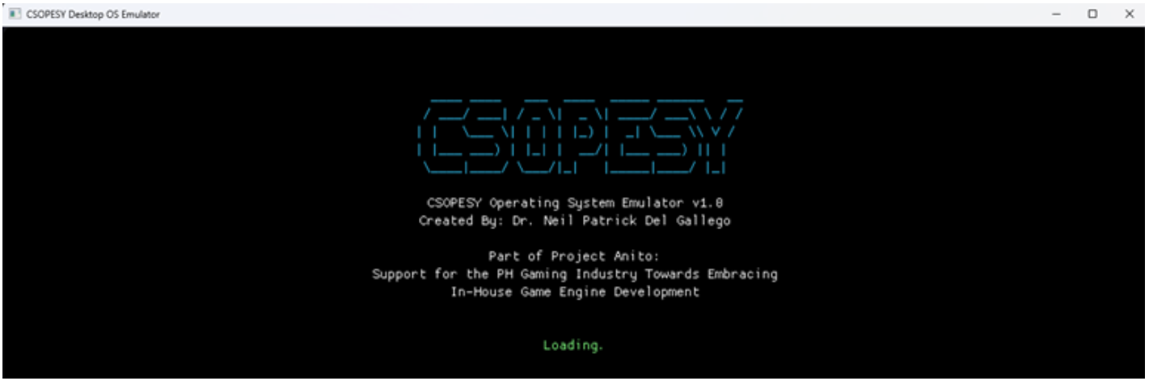
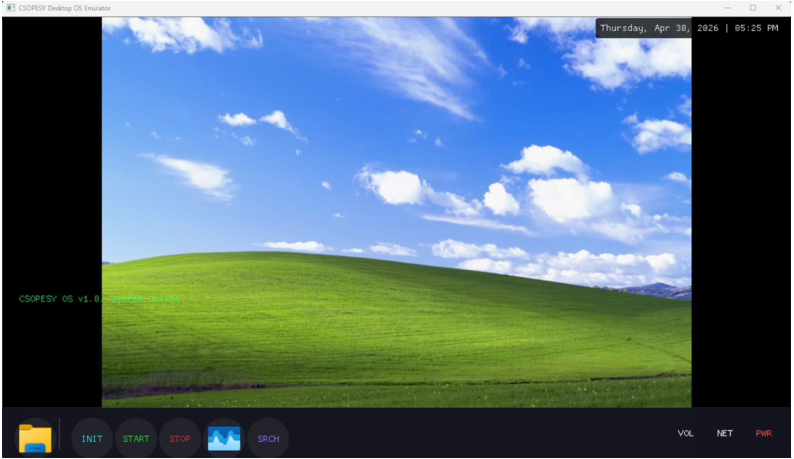

Checklist of Requirements
Your system must have ALL the following features implemented properly.

Requirement | Deskop
Description | A full-screen background that serves as the base layer of the OS. This is the first thing rendered each frame.  - Fills the entire application window  - Displays a wallpaper — either a solid color gradient, a pattern drawn using ImGui draw commands, or a loaded image texture  - Displays a real-time clock (current time, updated every frame) in a fixed corner of the screen  - Provide a PWR button that serves as a shutdown. The application must be closed using this button, and not by force exit.
Requirement | Taskbar
Description | A fixed panel (top or bottom of screen) that provides access to system functions and shows running applications.:  - “Contain at least three clickable icon buttons. It's up to you how to design these buttons. Two of these buttons must open up a unique UI screen, with placeholder information. Any UI screen with your own design or layout is acceptable. The third button must serve as the Task Manager.
Requirement | Task Manager
Description | A window that closely resembles the Windows task manager:  - Must have a placeholder table showing "Processes" and their respective CPU and memory usage  - Use dummy values on the Task Manager

ASSESSMENT METHOD
The project will be assessed through a black box quiz system in a time-pressure format. This is to minimize drastic changes or “hacking” your project to ensure the test cases are met. You should only modify the parameters and no longer recompile the project when taking the quiz.

Test cases, parameters, and instructions are provided per question, wherein you must submit a video file (.MP4), demonstrating your project. Some questions will require submitting PowerPoint presentations, such as cases explaining the details of your implementation.

IMPORTANT DATES
See AnimoSpace for specific dates.

Week 5 | Project submission

Submission Details
Aside from video files for the quiz, you need to prepare some of the requirements in advance, such as:
  - SOURCE - Contains your source code. Add a README.txt with your name and instructions on running your program. Also, indicate the entry class file where the main function is located. An alternative can be a GitHub link.
  - PPT – A technical report of your system containing:
  - Cover
  - Video Walkthrough
  - Architectural Diagram
  - Code Snippets
  - Provide a written discussion on how you designed your desktop-style OS
  - Video
  - Your video must be seamless and not cut. The minimum video quality should be at least 480p and a maximum of 720p. Please ensure that the font size of your IDE is large enough to be readable on video.
  - Maximum video size should be limited to 1GB.
  - You are not allowed to access/modify your code while performing the test case.
  - The video should always show you pressing Run/Debug from your IDE, which should initialize your program. Once running, you are not allowed to exit from your program and attempt to modify your code.
  - Not following upload instructions will invalidate your submission.
  - Ensure that your MP4 is directly embedded in your PPTX. It should be reflected in your total file size

Grouping
This is a group project. Each group can have a maximum of four members. All members of the group should be in the same section.

Grading Scheme
- You are to provide evidence for each test case, recorded through video. Each test case will have some points allocated. The test cases will be graded as follows:

Functional
No points | Partial points | Full points
The desktop emulator did not pass the test case. NO WORKAROUND is available to produce the expected output. | The desktop emulator did not pass the test case. A workaround is available to produce the expected output. | The desktop emulator passed the test case using varying inputs and produced the expected output.

